**Problem 1**

To verify that exist a difference between the two store we create at first a dataset with the difference of the mean price and conditions for the same product.

Then to perform a test we have to check that the data belong to multivariate normal distribution. We perform a Shapiro test and we obtain a p-value of 0.7428,so we can assume normality.

We perform a T2 test with the following hypothesis:

H0 : mean = 0 H1: mean != 0

We obtain a p-value of 0.01625523,so we at level 95% we reject the null hypothesis and we can say that exist a difference between the two stores.

We the plot the confidence region at level 95% of the difference of mean price and conditions between the two stores.

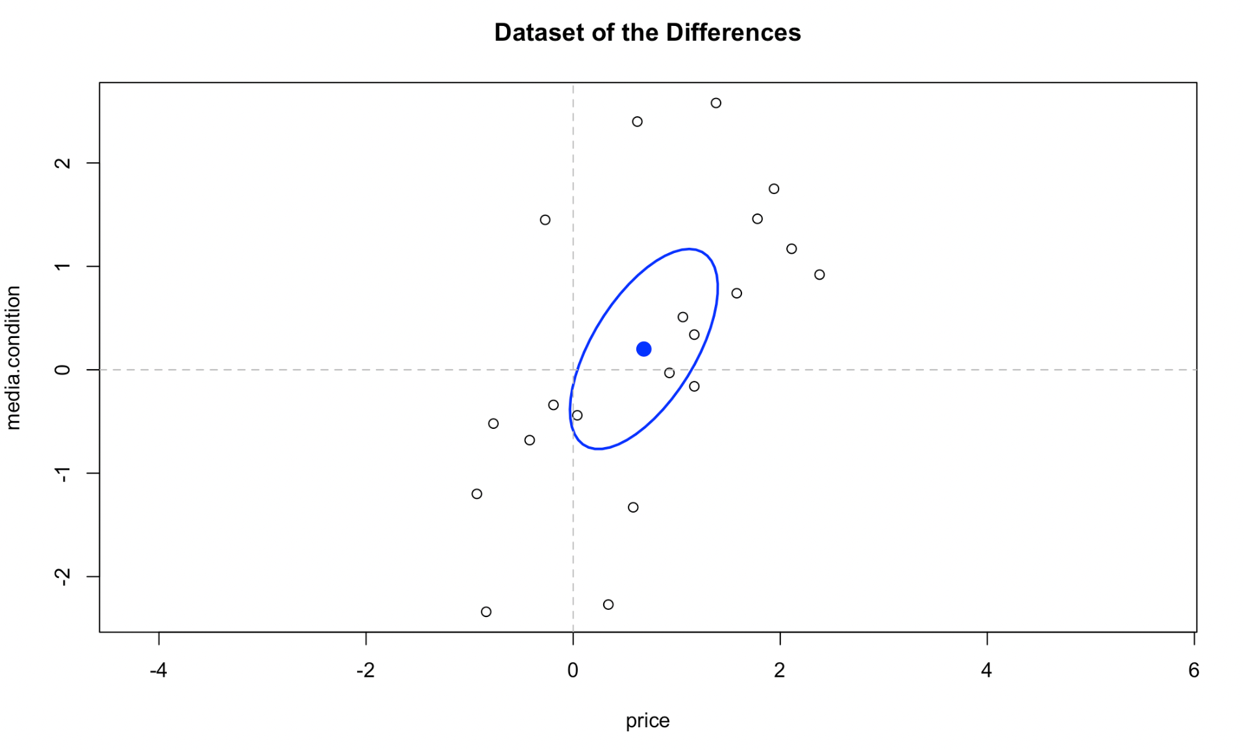

The point (0,0) which means same condition is slightly outside the confidence region, so we reject the hypothesis as we have shown before.

We now compute 4 simultaneous Bonferroni intervals on the mean and variance of the differences. We use the following formulas:

${BonfCI}_{1-α}\left({\underline{a}}_{i}^{'}\underline{μ}\right)=[ {\underline{a}}_{i}^{'} \overline{\underline{X}} ±t_{1-\frac{α}{2k}} \left(n-1\right)\sqrt{\frac{{\underline{a}}_{i}^{'}S{\underline{a}}_{i}}{n}}]$

${BonfCI}_{1-α}\left({\underline{a}}_{i}^{'}S\right)=[\frac{ {n*\underline{a}}_{i}^{'}S{\underline{a}}_{i}}{{χ^{2}}_{1-\frac{α}{2k}}},\frac{ {n*\underline{a}}_{i}^{'}S{\underline{a}}_{i}}{{χ^{2}}_{\frac{α}{2k}}}]$

where a_1 = (1,0) and a_2 = (0,1) and obtain the following results:

inf center sup

ICmean_PRICE 0.0480422 0.683000 1.317958

ICmean_CONDITION -0.6597456 0.200500 1.060746

ICvar_PRICE 0.5322847 1.059612 2.841861

ICvar_CONDITION 0.9770104 1.944921 5.216247

We can see that 0 belongs to the confidence interval of the mean of the condition at level 95% but this is not enough to show that they are the same for both, in fact the T2 test rejected the simultaneous hypothesis of both equal to 0.